Since their formation back in 2009, Tradish have brought their eclectic embrace of Irish music to hundreds of enthusiastic audiences around Europe. Tradish connect the old and the new, the past and the present, respecting the roots while still keeping the music fresh and alive.
.
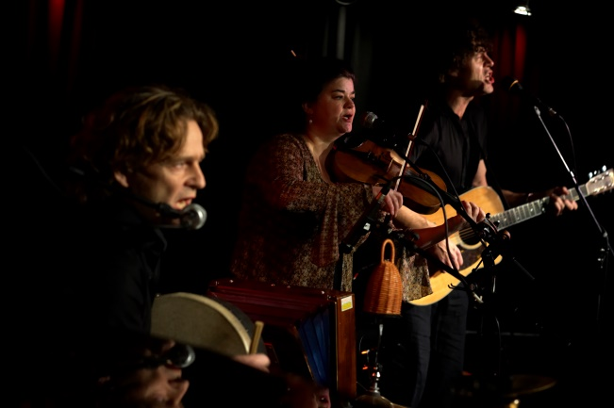
Tradish are:
John Pilkington: vocals, guitar, bouzouki
Louise Ring Vangsgaard: fiddle, viola, vocals
Brian Woetmann: bodhrán, percussion, mandolin, vocals, stepping

The latest album Handmade tales is a collection of 15 tracks, handcrafted for acoustic instruments, each with its own story, each telling its own tale. It’s a distillation of the band’s special sound, combining original numbers with traditional material. It’s a snapshot of how Tradish’s distinctive sound has evolved after many years of playing together: the sound of 3 voices and 6 hands picking, bowing and beating instruments handmade from wood, strings and goatskin.

Traditional Irish music has grown into a mighty tree over the past 200 years, with branches stretching around the world. The band’s previous album Roots and Shoots, took us on a journey that started with a crazy trip through Galway, and then out into the world beyond, drawing on the energy that flowed from the roots of Irish music. The combination of Irish emigration and the sheer passion of its traditional music had blossomed into a truly global phenomenon. Enthusiastic reviews from around Europe led to Tradish being chosen as one of the 10 bands representing Denmark as part of the “Danish Roots – Growing in the world” music export project.

Three tours in Greenland have provided the opportunity to soak up inspiration from some of the Greenlandic song tradition. “Nuilersup Qilaap Seequinersuata”, a beautiful Greenlandic song, became a feature of the concert repertoire and is included on Handmade tales.
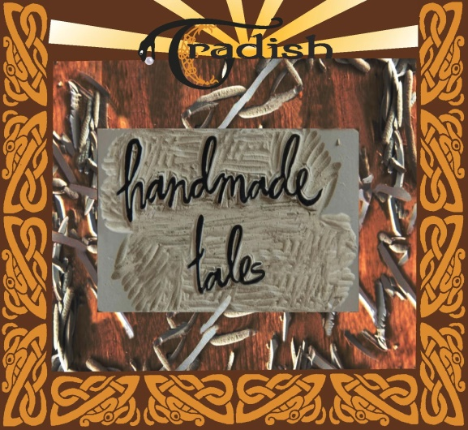
The past few years has also seen a series of acclaimed concerts with Gunilla Odsbøl, a phenomenal stepdancer and winner of the European Irish Stepdance Championship. Gunilla’s stepping adds a new element to the Tradish sound, with Gunilla’s feet featuring on one of the album’s dance numbers.

In 2021, Tradish continue to perform their Handmade tales at concerts and festivals thoughout Scandinavia and beyond.

contact and info: www.tradish.dk pilk@email.dk
tel: (+45) 21403430

